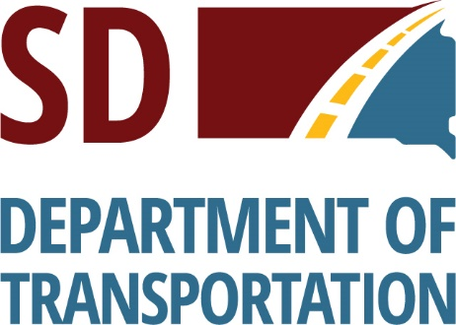 | Public Information
P-PH 0037(161)133, Beadle & Spink County, PCN 06VV

S.D. Highway 37 From S.D. Highway 28, South 12 Miles

Grading & Interim Surfacing

Public Meeting Information @
https://dot.sd.gov/projects-studies/projects/public-meetings#listItemLink_1806

The South Dakota Department of Transportation provides services without regard to race, color, gender, religion, national origin, age or disability, according to the provisions contained in SDCL 20-13, Title VI of the Civil Rights Act of 1964, the Rehabilitation Act of 1973, as amended, the Americans With Disabilities Act of 1990 and Executive Order 12898, Federal Actions to Address Environmental Justice in Minority Populations and Low-Income Populations, 1994.

Any person who has questions concerning this policy or who believes they have been discriminated against should contact the Department’s Civil Rights Office at 605-773-3540.

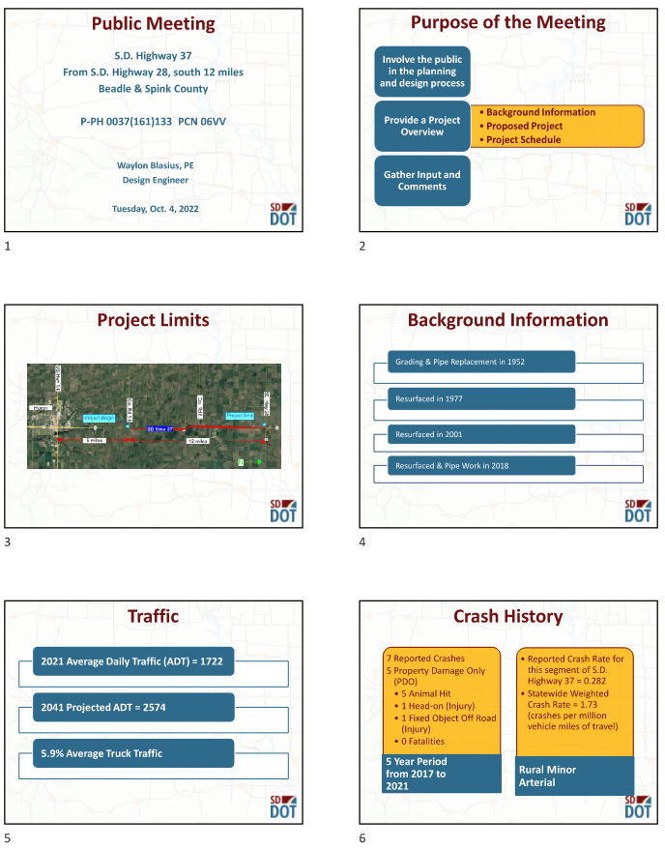
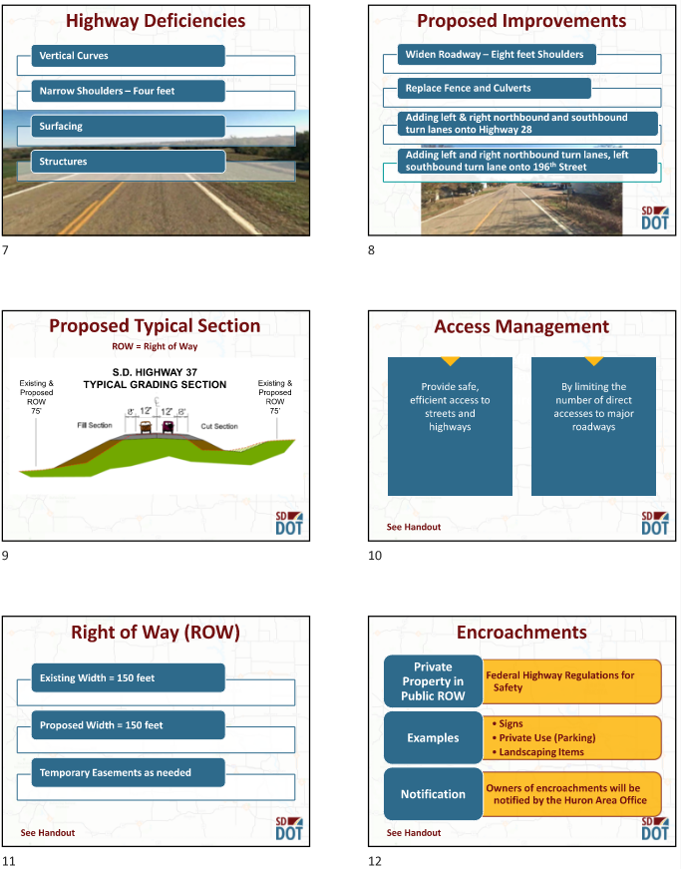

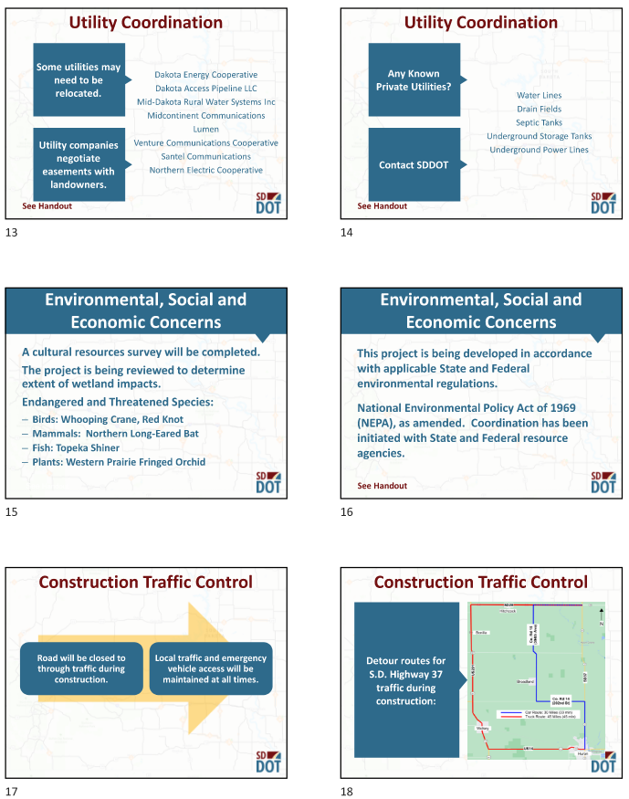

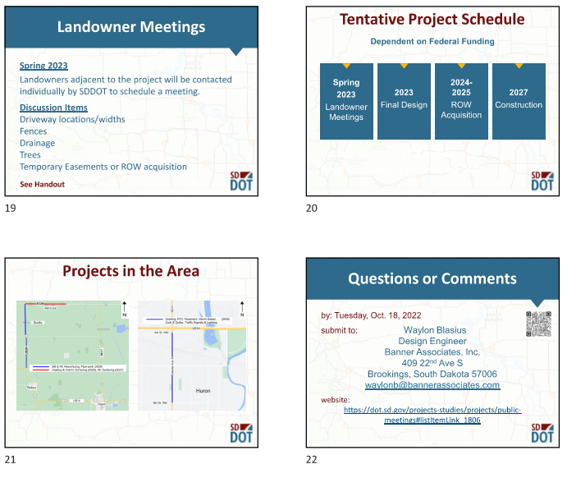

Access Management
South Dakota’s Commitment to Safety and Smart Investment Decisions in Transportation
What is Access Management?
Access Management is the process of providing highway entrances only at locations where they can be provided safely and efficiently.
Consider that each access point added to an undivided highway in an urban or suburban area increases the annual crash rate by 11 to 18 percent on that highway segment. In rural areas, each added access point increases the annual crash rate by 7 percent. Overall, driveway-access crashes alone cost South Dakota approximately $36.5 million each year.
Each additional access point also contributes to congestion. The more driveways on a street the more places where people are slowing, changing lanes and turning. A five-lane street can quickly become a parking lot when there are many driveways in each block. When that happens, our valuable transportation investments are wasted and access to adjacent businesses is restricted.
Controlled access facilities are segments of highway where either no access or only limited access to the highway is allowed. Interstate highways are an example of controlled access facilities where no access to the highway is allowed.
Good access depends on the following:
  - Limiting the number of conflict points (places where there is a potential for crashes)
  - Separating conflict areas
  - Reducing interference with through traffic
  - Providing good on-site circulation and storage
  - Properly spaced traffic signals
How does Access Management affect businesses?
Studies have shown that access management can provide three benefits to businesses adjacent to highways:
  - Making sure that drivers can get in and out of businesses without being blocked by other traffic
  - Making the highway more attractive by reducing congestion
  - Extending the business’ effective service area by reducing travel times
These benefits come not from having many driveways, but by having well-planned, well-located, high-capacity access points on the highway.
Even skeptical business owners have found that proper access management results in an improved business climate, as customers can easily get in and out of their business establishment.
For more information, please contact:
Joseph Sestak
Access Management Engineer
1306 West 31st Street
Yankton, South Dakota 57008
Phone: (C) 605-661-2255 (O) 605-668-2929 Ext. 1302007
E-Mail: Joseph.Sestak@state.sd.us
Right of Way Information
Individual Landowner Meetings
During the early stages of the project’s design, SDDOT will schedule a meeting with individual landowners having property adjacent to the project. See the following page for an explanation of the landowner meeting.

Property Acquisition Offer
After the project construction plans have been prepared and the right of way limits have been established, you may be contacted by an appraiser or negotiations agent to visit with you for that portion of your property that is needed for construction of the project. Your property will be valued and a written offer presented to you by a negotiating agent who will contact you for an appointment to make the written offer.

Relocation Assistance Program
This program provides a variety of services and payments to owners and tenants who have personal property affected by the right of way being acquired for the project.

Relocation payments are in addition to payments made for the real property being acquired. To preserve your eligibility for payments, do not move property until you have received a written relocation offer or have contacted John Keyes of the SDDOT Right of Way Program in Pierre. His phone number is 605-773-3746. Anyone not satisfied with the relocation offer made to them may appeal using the procedures described in the Relocation Brochure.

The landowner may be reimbursed for various fair and reasonable incidental expenses that may be incurred during the transfer of property to the State depending on impacts to personal property and qualifications.

Right of Way Information Brochures
Two brochures “Better Roads Brochure” and “Relocation Assistance Brochure” have been prepared which explain the SDDOT’s Right of Way process. They provide information on your rights regarding the acquisition of your property and the benefits available to you with regard to the Relocation Assistance Program. These brochures are available at this meeting on the “Sign-in” table. Please feel free to take a copy of each with you. These brochures are available at the following SDDOT website: https://dot.sd.gov/inside-sddot/forms-publications/brochures

Individual Landowner Meetings
The purpose of this meeting is to provide you with an opportunity to comment on various issues pertaining to the design of this highway project as it relates to your property.

The following topics will be discussed at the meetings. Please note that not all topics will apply to every property owner.

- Permanent purchase and/or temporary use of your property.
- Locations and widths of entrances to your property: The standard South Dakota Department of Transportation (SDDOT) entrance-width for rural highways is 24 feet. Note: In general, existing entrance widths along rural State Highways are 24 feet or smaller. A maximum width of 40 feet is allowed at locations where it is deemed appropriate and necessary. Entrances in urban areas can vary from 16 feet to 40 feet.
The goal of the SDDOT is to provide property owners located adjacent to the project with the access they need, and at the same time, enhance highway safety and reduce project costs. In some instances, the SDDOT may seek to combine duplicate entrances. For example, if your property has two or three entrances to the same property that are located close to each other, we would ask you to assess your current entrance needs and consider one entrance location that will meet those needs.
- Permanent fencing adjacent to the highway: SDDOT’s fencing policy allows for the replacement of all disturbed fence with like-kind fence.
Two fence types are typically installed: Type 2: 4-strand barbed wire with 8-inch wire spacing, and Type 6: 32-inch woven wire with 1 strand of barbed wire on the bottom and 2 strands of barbed wire on the top. Page 12 of the “Better Roads Brochure” contains added discussion of your permanent fencing options. This brochure will be available at the meeting.
- Temporary fencing adjacent to the highway: Do you anticipate having livestock in pastures located adjacent to the proposed project during highway construction activities?
- Are you aware of any waterlines, drainfields, septic tanks, underground storage tanks, underground power lines, etc. that are located adjacent to the project and may be impacted by construction activities?
- Are there any highway-related drainage or flooding problems located along your property or elsewhere along this section of highway?
- Possible sites for gravel and additional fill material: Are you aware of potential material available for construction that might be located adjacent to the highway?
- Temporary access during construction activities.
Please review your property and be prepared to discuss the above issues, as well as any other issues that you feel are unique to your property. No offers to acquire property will be made at these meetings since revisions to the plans may occur from your input.
Encroachments in ROW
Federal Regulations (CFR 23.1) require that the State Highway Department (SDDOT) will be responsible for preserving such ROW free of all public and private installation, facilities, and encroachments.

No improvements shall be allowed to remain in the ROW unless they are deemed in the best interest of the pubic and will not impair the highway or interfere with the free and safe flow of traffic.

Encroachments are any private property or improvement in the public ROW that is not approved by permit such as:

- Landscaping Items
- Fence
- Signs
- Buildings
- Etc.

SDDOT Staff will survey the project limits to identify all encroachments. Prior to the project being let to contract, landowners will be contacted by the SDDOT or City Government regarding how each encroachment will be addressed or handled. If it is determined that the removal of an encroachment is required, it will be the landowner’s responsibility to remove the encroachment.

For additional information, please contact:

Brad Letcher
Area Engineer
SDDOT Huron Area Office
901 Dakota Ave N
Huron, SD 57350
Phone: 605.353.7140
E-Mail: Brad.Letcher@state.sd.us

Environmental, Social & Economic Impacts and Advanced Utility Coordination
Environmental, Social & Economic Impacts
- Project will comply with all state and federal environmental regulations.

- No splitting of neighborhoods will occur because of this project.

- Project will be coordinated with the following state and federal agencies:
- SD Dept. of Environment & Natural Resources
- SD Dept. of Game, Fish & Parks
- US Fish & Wildlife Service
- State Historic Preservation Office
- US Forest Service

- For additional information, please contact:

Chad Babcock
Environmental Engineer Manager
SDDOT Office of Administration
700 E. Broadway Ave.
Pierre, SD 57501
Phone: 605.773.3721
E-Mail: Chad.Babcock@state.sd.us

Advanced Utility Coordination
- Highway projects may require adjustments or relocation of existing utilities located along or crossing the highway project. The SDDOT has an "Advanced Utility Coordinating Process" in place that addresses all existing utility involvement. This process involves meeting with the utility owner and project designers to review any conflicts and determine the most cost-effective option of changing the design to avoid the existing utility or adjusting the utility. If the utility is required to relocate, all replacement utility easement acquisition and relocation work will be addressed and coordinated between the landowner and the utility company.

- For additional information, please contact:

Waylon Blasius
Road Designer
Banner Associates, Inc.
409 22nd Ave S
Brookings, SD 57006
Phone: 605.692.6342
E-Mail Address: waylonb@bannerassociates.com
Wetland Mitigation
Registry Form
Federal regulations require that unavoidable wetland impacts caused by highway construction be mitigated. Examples of acceptable wetland mitigation include:
- Wetland creation
- Wetland restoration – plugging an existing, drained wetland
- Wetland enhancement - adding buffer around an existing wetland.

The South Dakota Department of Transportation (SDDOT) may participate in the cost of wetland creation/restoration/enhancement, if the wetland can be used to mitigate wetland impacts caused by highway construction.

If you are interested in creating, restoring, or enhancing wetlands on your property, please complete the attached form and mail to:

Chad Babcock
Environmental Engineer Manager
SDDOT Office of Administration
700 E. Broadway Ave.
Pierre, SD 57501
Phone: 605.773.3721
E-Mail: Chad.Babcock@state.sd.us

Your name will be added to the SDDOT Wetland Mitigation Registry and a SDDOT representative will contact you with additional information.

Yes, I am interested in assisting the SDDOT to mitigate wetland impacts by creating or restoring wetlands on my property.

Name:
Address:

Phone #: Email:

Location of property: 1/4 of Section
Township , Range , County

Please note: Completion of this form does not commit either you or the SDDOT to a mitigation project. It is a statement of interest only.

Public Comments
P-PH 0037(161)133, Beadle & Spink County
PCN 06VV
S.D. Hwy 37 - Fm S.D. Hwy 28, South 12 Miles
Grading & Interim Surfacing

Name: Date:
Address:
Telephone #: and/or Cell #:
Written testimony will be included in the meeting record.
Please submit comments by Tuesday, Oct. 18, 2022 to:

Waylon Blasius
Road Designer
409 22nd Ave S
Brookings, SD 57006
E-Mail Address: waylonb@bannerassociates.com

